PROJECT REPORT OF INDUSTRY ORIENTED HANDS ON EXPERIENCE (IOHE)
ON

Predicting Student Academic Performance Using Machine Learning Techniques

submitted in partial fulfilment of the requirements for the award of degree of

BACHELOR OF ENGINEERING
In
COMPUTER SCIENCE AND ENGINEERING

Submitted by: Supervised By:
Nitin Choudhary Dr. Preeti Saini
2210991998 Associate Professor
Nikshay Katoch Chitkara University
2210991984
Kavya Mittal
2210991778



DEPARTMENT OF COMPUTER SCIENCE AND ENGINEERING

CHITKARA UNIVERSITY INSTITUTE OF ENGINEERING AND TECHNOLOGY
CHITKARA UNIVERSITY, PUNJAB, INDIA

CONTENTS

S.No. | Title | Page No.
 | Acknowledgement | 4
 | Abstract | 5
1 | Introduction | 6-7
2 | Methodology | 8-10
3 | Tools and Technologies | 11-12
4 | Implementation | 13-20
5 | Major Findings/Outcomes/Output/Results | 21-22
6 | Conclusion and Future Scope | 22-23
 | References | 24
 | Appendices | 25

DECLARATION

I hereby certify that the work which is being presented in the project report entitled “Predicting Student Academic Performance Using Machine Learning Technique” in partial fulfilment of requirement for the award of the degree of Bachelor of Engineering (Computer Science and Engineering) submitted in the department of Computer Science and Engineering at Chitkara University Institute of Engineering and Technology, Chitkara University, Punjab, India, is an authentic record of my own work carried out under the supervision of Dr. Preeti Saini .The matter presented in this project report has not been submitted in any other university/institute for the award of any degree.

Place: Rajpura Nikshay Katoch
Date : 14-5-2026 2210991984
Nitin Choudhary
2210991998
Kavya Mittal
2210991778

This is to certify that the above statement made by the candidate is correct to the best of my knowledge and belief.

Dr. Preeti Saini
Associate Professor
Department of Computer Science and Engineering
Chitkara University Institute of Engineering and Technology,
Chitkara University, Punjab, India

ACKNOWLEDGEMENT

I would like to express my sincere gratitude to my project guide, faculty members, and everyone who supported me during the completion of this report. Their guidance, encouragement, and valuable suggestions helped me successfully complete the project titled “Predicting Student Academic Performance Using Machine Learning Techniques” I also thank my friends and family for their continuous support and motivation throughout the project.

Abstract

Student academic performance prediction has become an important research area in the field of Machine Learning and educational data analysis. Educational institutions collect large amounts of data related to attendance, study habits, assignments, and examination performance. Analysing this data manually is time-consuming and less efficient.
This project focuses on predicting student academic performance using machine learning techniques. The system analyses various academic factors such as study time, attendance, previous grades, and classroom performance to identify students who may require additional academic support. Three machine learning models—Logistic Regression, K-Nearest Neighbours, and Support Vector Machine—were implemented and compared.
The results indicate that the Support Vector Machine model achieved the highest accuracy among all models, while KNN provided balanced and stable performance. The project demonstrates how machine learning can help educational institutions improve academic decision-making and student performance analysis.

1. Introduction

Educational institutions generate large amounts of student-related data every year. This data includes attendance records, internal assessment marks, assignment performance, study behaviour, and examination scores. Traditional methods of student evaluation mainly focus on final examination results and often fail to identify weak students at an early stage.
With the advancement of machine learning technologies, educational systems can now use predictive analysis to improve academic performance monitoring. Machine learning algorithms can analyse patterns in student data and predict future academic outcomes more efficiently than traditional methods.
The main objective of this project is to develop a machine learning-based system that predicts student academic performance using historical educational data. The system helps educators identify students who may need academic guidance or additional support.

1.1 Background
Educational institutions generate large amounts of student-related data such as attendance records, assignment scores, study hours, classroom participation, and examination results. Analysing this data manually is time-consuming and often ineffective in identifying students who may struggle academically. Traditional evaluation methods mainly focus on final examination performance and do not provide early prediction or academic intervention.
With the advancement of Machine Learning techniques, educational data can now be analysed more efficiently to predict student academic performance. Machine learning models help identify patterns in student behaviour and learning performance, enabling institutions to provide early support to students who may be at academic risk.
This project focuses on predicting student academic performance using machine learning algorithms such as Logistic Regression, K-Nearest Neighbours, and Support Vector Machine. The system aims to improve academic decision-making through data-driven prediction techniques.

1.2 Problem Statement
- Traditional student evaluation methods mainly focus on final examination results.
- Educational institutions face difficulty identifying weak students at an early stage.
- Manual analysis of large student datasets is time-consuming and inefficient.
- Existing systems may not provide accurate academic performance prediction.
- Factors such as attendance, study habits, and previous grades are often not analysed effectively.
- Lack of predictive systems can reduce the ability to provide timely academic support.
- Educational institutions require data-driven methods for better academic decision-making.
- There is a need for an automated system that can predict student performance accurately using machine learning techniques.

1.3 Objectives
- To predict student academic performance using machine learning techniques.
- To analyse student data such as attendance, study time, and previous grades.
- To identify academically weak students at an early stage.
- To compare the performance of different machine learning algorithms.
- To improve educational decision-making through predictive analysis.
- To reduce manual effort in academic performance evaluation.
- To develop an accurate and efficient student prediction system.
- To support educational institutions in improving student outcomes.

1.4 Scope of the Project
- Collection and preprocessing of student datasets
- Feature selection and data normalization
- Implementation of Logistic Regression, KNN, and SVM algorithms
- Training and testing of machine learning models
- Performance evaluation using accuracy and F1-score
- Prediction of student academic outcomes
- Comparative analysis of different machine learning techniques

2. Methodology
The methodology of the project “Predicting Student Academic Performance Using Machine Learning Techniques” follows a systematic process that includes data collection, preprocessing, model training, testing, and performance evaluation. The objective is to analyze student-related data and predict academic performance accurately using machine learning algorithms.

2.1 Data Collection
The dataset used in this project was collected from the UCI Machine Learning Repository. The dataset contains various academic and behavioural attributes related to student performance.

Dataset Attributes Include:
- Attendance
- Study time
- Previous grades
- Assignment performance
- Classroom participation
- Academic records
The collected data serves as the foundation for training and testing the machine learning models.

2.2 Data Preprocessing
Data preprocessing is an important step in machine learning because raw datasets often contain missing values, duplicate records, and inconsistent formats.

Preprocessing Techniques Used:
- Handling missing values
- Removing unnecessary attributes
- Encoding categorical data
- Feature selection
- Data normalization
These preprocessing techniques improve the quality and efficiency of the dataset before model implementation.

2.3 Dataset Splitting
After preprocessing, the dataset is divided into:
- Training Dataset (80%)
- Testing Dataset (20%)
The training dataset is used for model learning, while the testing dataset is used for evaluating prediction performance.

2.4 Machine Learning Algorithms
The following machine learning algorithms were implemented in the project:

A. Logistic Regression
Logistic Regression is a supervised learning algorithm used for classification tasks. It predicts student performance based on probability values and helps classify students into performance categories.

B. K-Nearest Neighbours
KNN predicts student performance by analysing similarities between neighbouring data points. The algorithm classifies students based on the nearest available training examples.

C. Support Vector Machine
SVM is a classification algorithm that identifies the best decision boundary between classes. It performs effectively for complex educational datasets and provides high prediction accuracy.

2.5 Model Training
The selected machine learning algorithms are trained using the training dataset. During this phase, the models learn patterns and relationships between student attributes and academic outcomes.
The training process helps the system understand how different academic factors influence student performance.

2.6 Model Testing and Evaluation
After training, the models are tested using the testing dataset to measure prediction performance.

Evaluation Metrics Used:
- Accuracy
- Precision
- Recall
- F1-Score
- Confusion Matrix
These metrics help compare the efficiency and reliability of different machine learning models.

2.7 Result Analysis
The performance of Logistic Regression, KNN, and SVM is compared based on prediction accuracy and classification performance.
The analysis helps determine which algorithm provides the most accurate results for predicting student academic performance. Among the implemented models, SVM achieved the highest accuracy, while KNN provided balanced performance.

3. Tools and Technologies
The project “Predicting Student Academic Performance Using Machine Learning Techniques” was developed using various programming tools, machine learning libraries, and data analysis technologies. These tools helped in data preprocessing, model training, testing, and performance evaluation.

3.1 Python
Python was used as the main programming language for implementing the machine learning models. It provides simple syntax, extensive libraries, and strong support for data analysis and predictive modelling.

Purpose:
- Data processing
- Machine learning implementation
- Model training and testing
- Performance evaluation

3.2 Pandas
Pandas is a Python library used for data manipulation and analysis. It helps handle datasets efficiently using Data Frames.

Purpose:
- Reading datasets
- Data cleaning
- Handling missing values
- Organizing and preprocessing data

3.3 NumPy
NumPy is a numerical computing library used for mathematical and array operations.
Purpose:
- Numerical calculations
- Matrix operations
- Data transformation
- Mathematical computations

3.4 Scikit-learn
Scikit-learn is a machine learning library used for implementing classification algorithms and evaluating model performance.
Purpose:
- Logistic Regression implementation
- KNN implementation
- SVM implementation
- Dataset splitting
- Accuracy and F1-score calculation

3.5 Jupiter Notebook
Jupiter Notebook was used as the development environment for coding, testing, and visualization.
Purpose:
- Writing and executing Python code
- Data visualization
- Model experimentation
- Result analysis

3.6 Machine Learning Algorithms Used
A. Logistic Regression
Used for probability-based classification and prediction.

B. K-Nearest Neighbours
Used for distance-based classification using nearest data points.

C. Support Vector Machine
Used for identifying the best decision boundary for accurate classification.

4. Implementation
The implementation of the project “Predicting Student Academic Performance Using Machine Learning Techniques” includes dataset collection, preprocessing, model training, testing, and performance evaluation. The system was developed using Python and machine learning libraries to predict student academic performance.

4.1 Dataset Collection
The dataset was collected from the UCI Machine Learning Repository. It contains student-related attributes such as attendance, study time, previous grades, and assignment performance.

4.2 Data Preprocessing
The dataset was pre-processed before model implementation.

Preprocessing Steps:
- Handling missing values
- Encoding categorical data
- Feature selection
- Data normalization
These steps improved data quality and model performance.

4.3 Dataset Splitting
The dataset was divided into:
- 80% Training Data
- 20% Testing Data
The training data was used for learning, while the testing data was used for evaluation.

4.4 Model Training and Testing
The models were trained using the training dataset and tested using the testing dataset to predict student academic performance.

4.5 Performance Evaluation
The models were evaluated using:
- Accuracy
- Precision
- Recall
- F1-Score
- Confusion Matrix
Among all models, SVM achieved the highest accuracy, while KNN provided balanced performance.

4.6 Screenshots

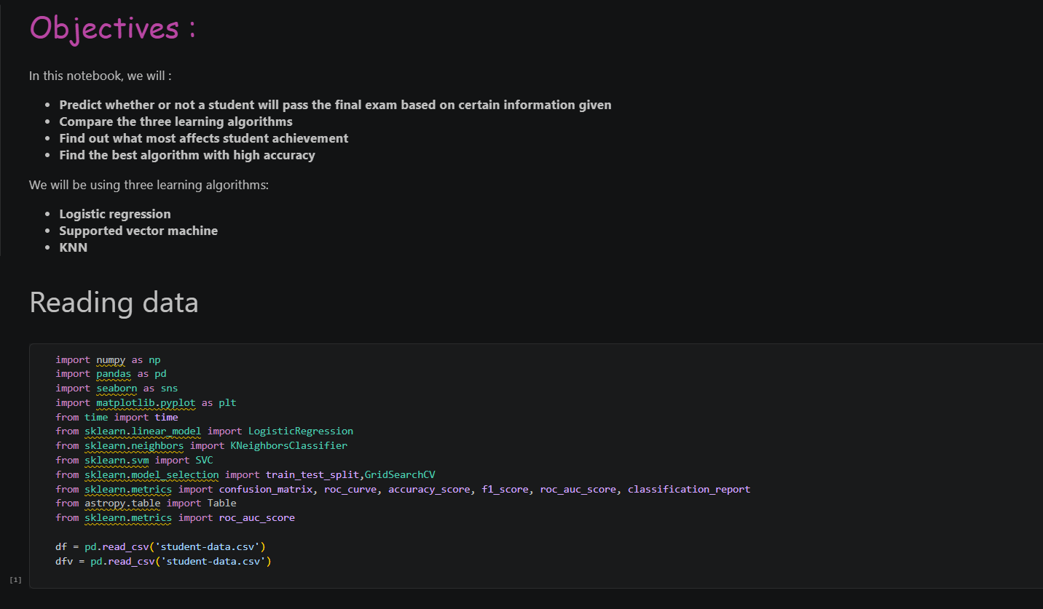

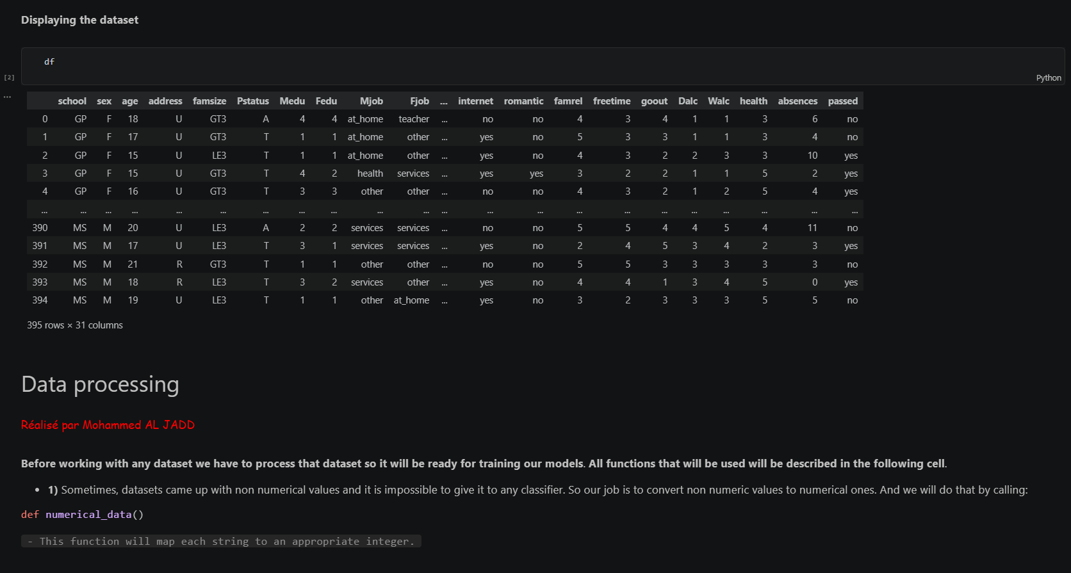

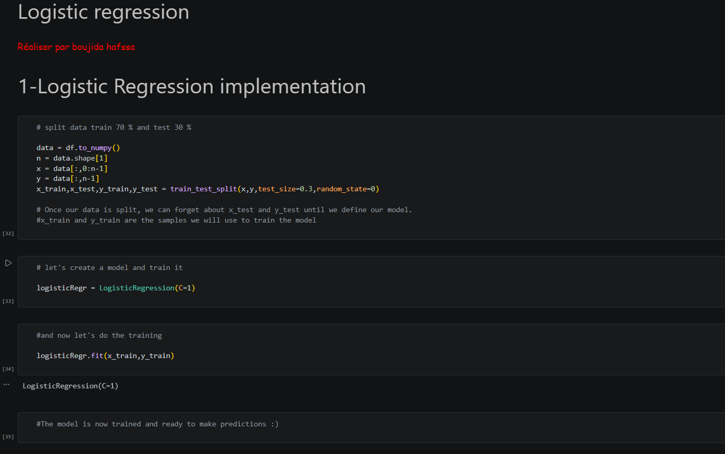

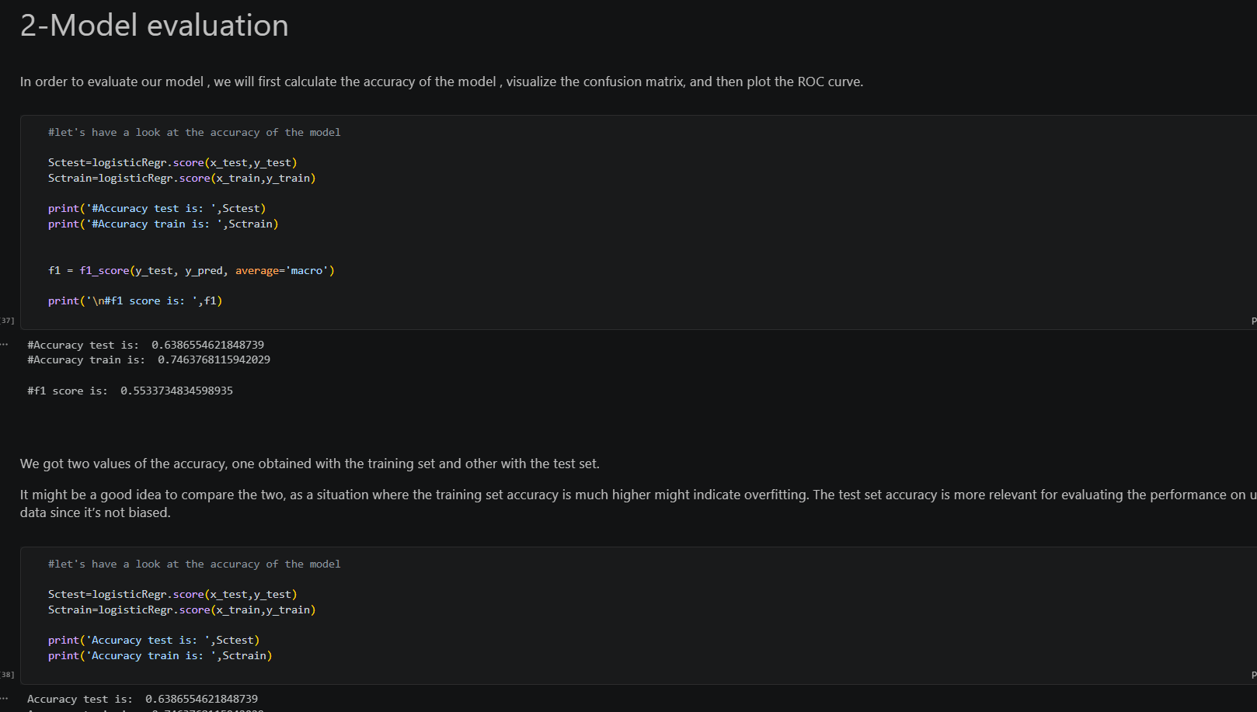

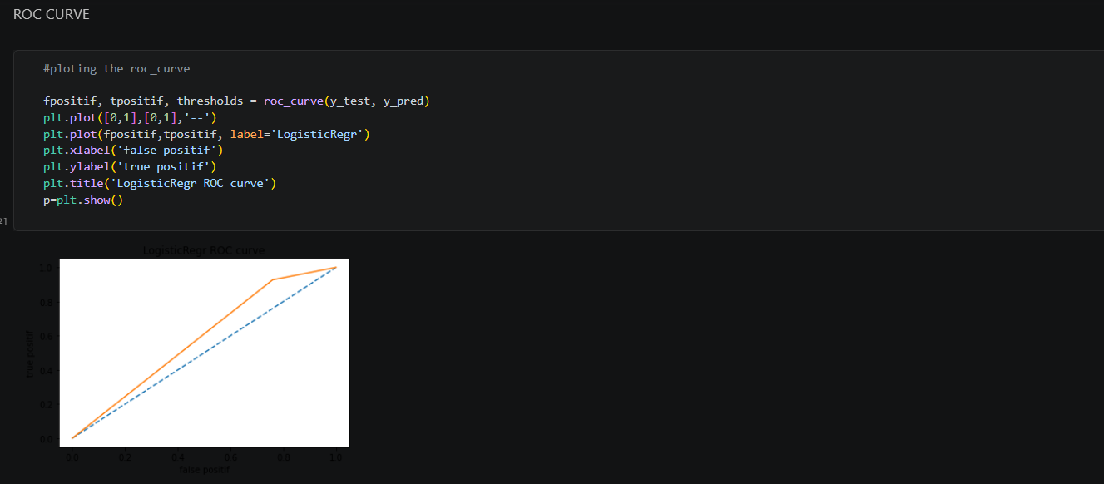

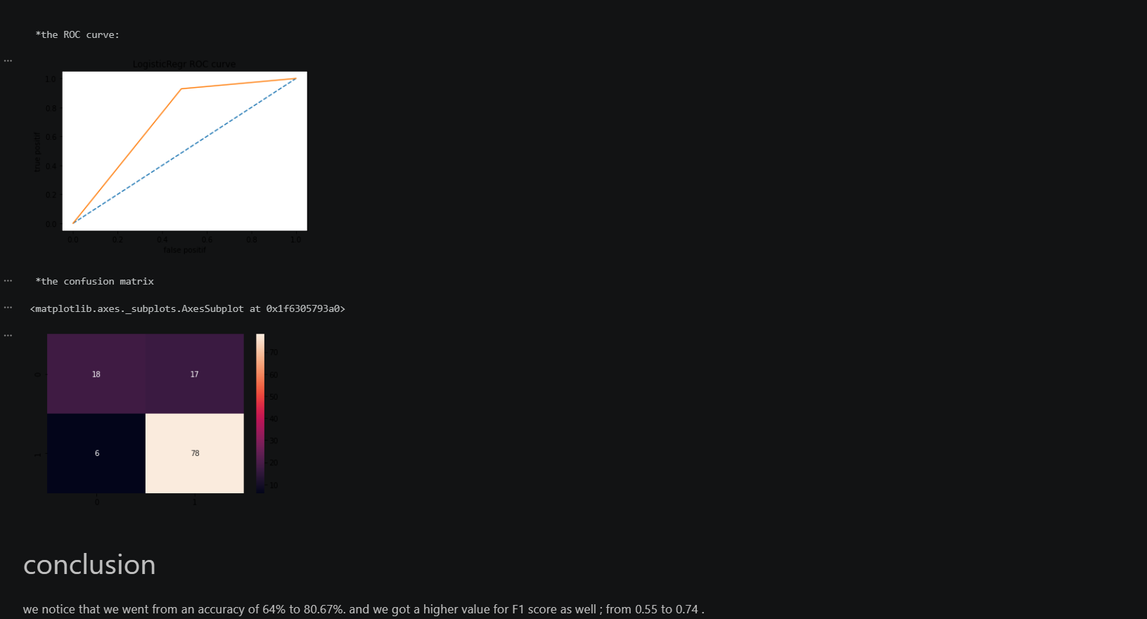

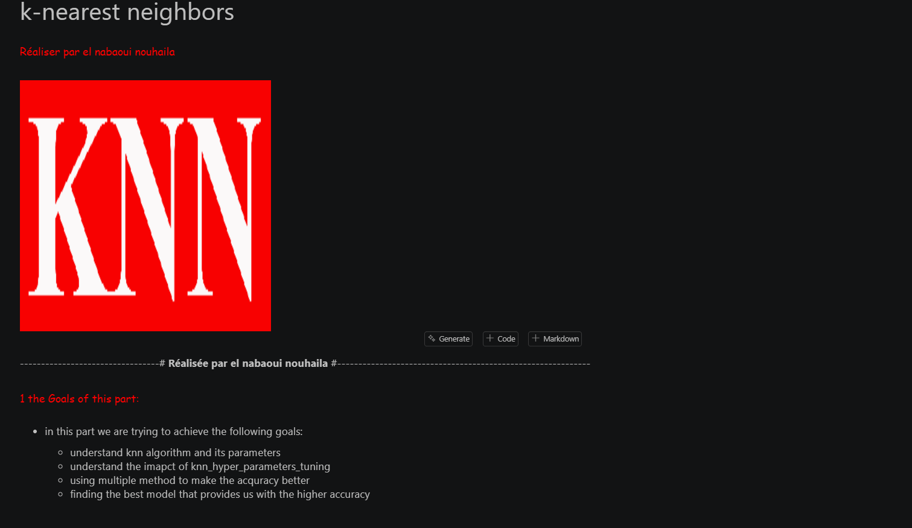

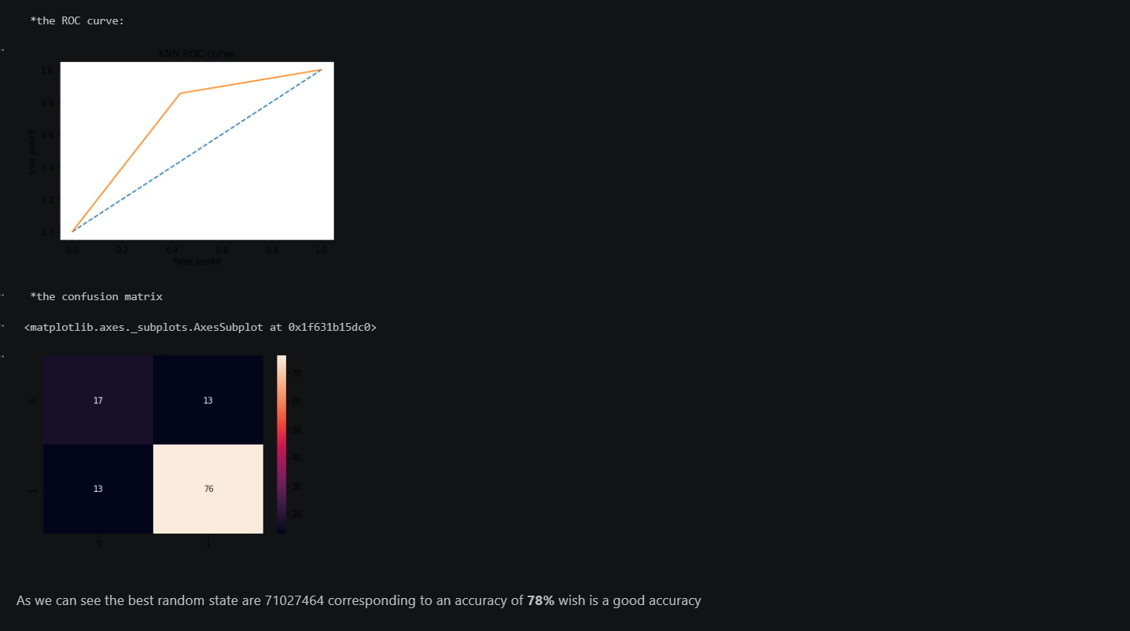

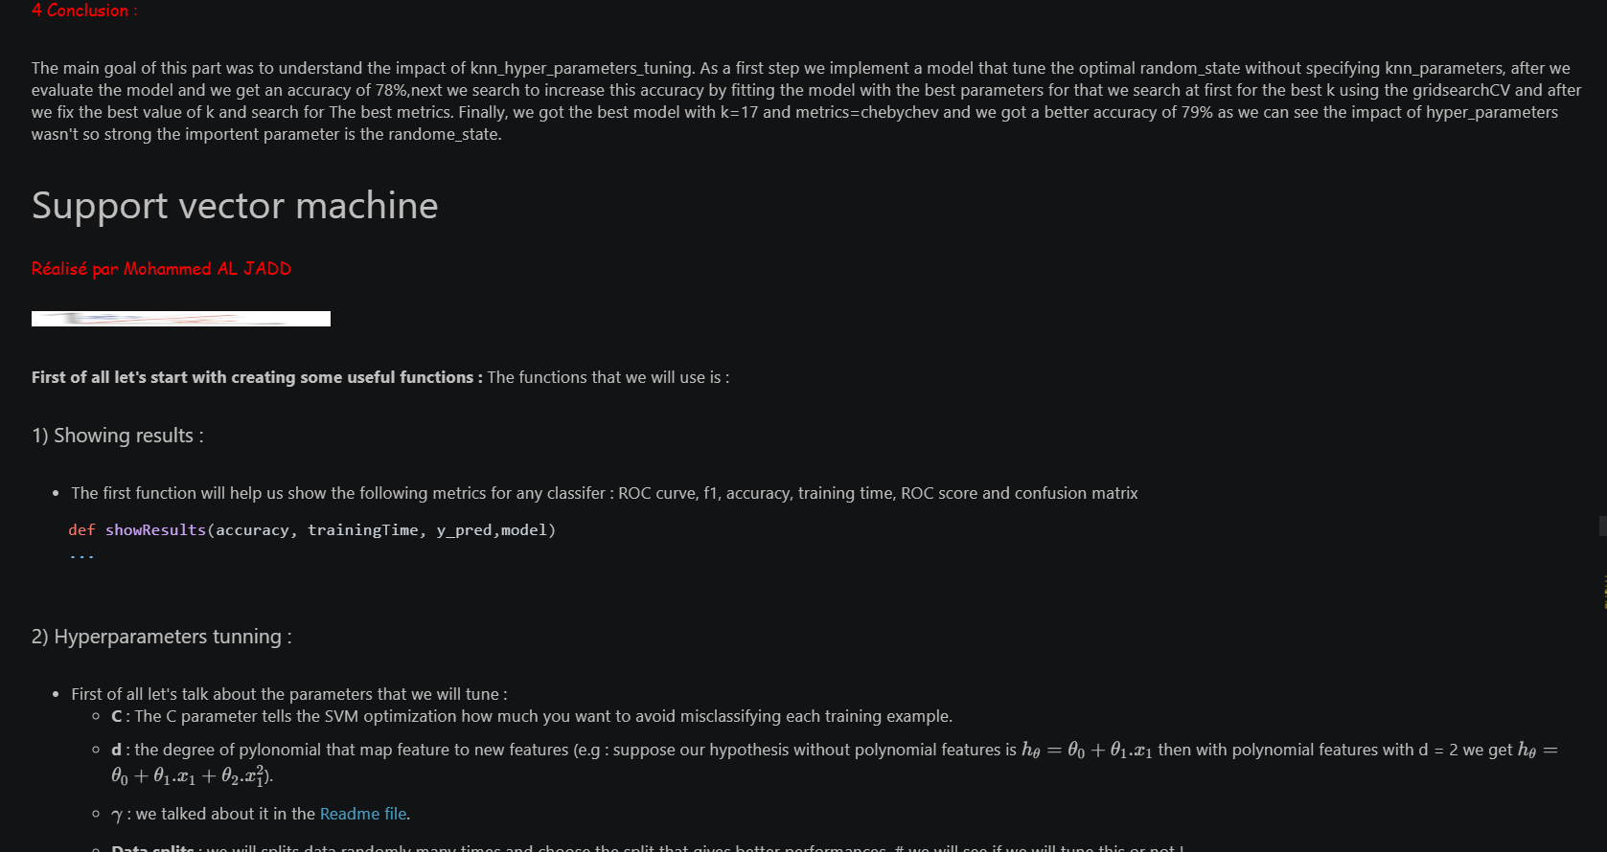

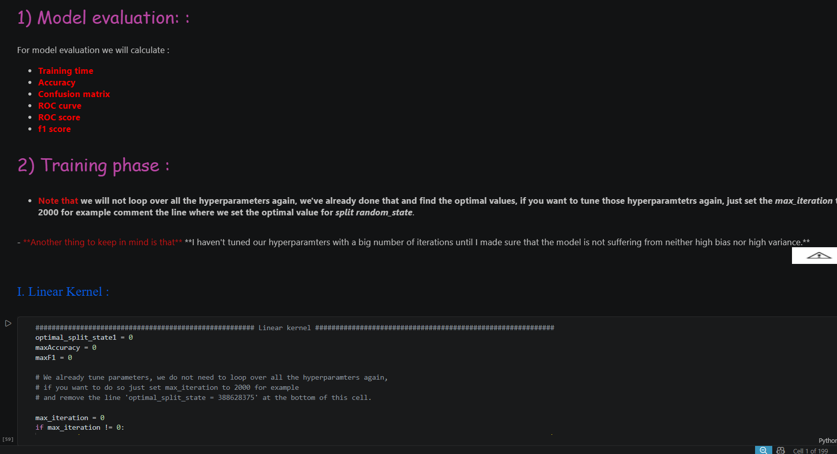

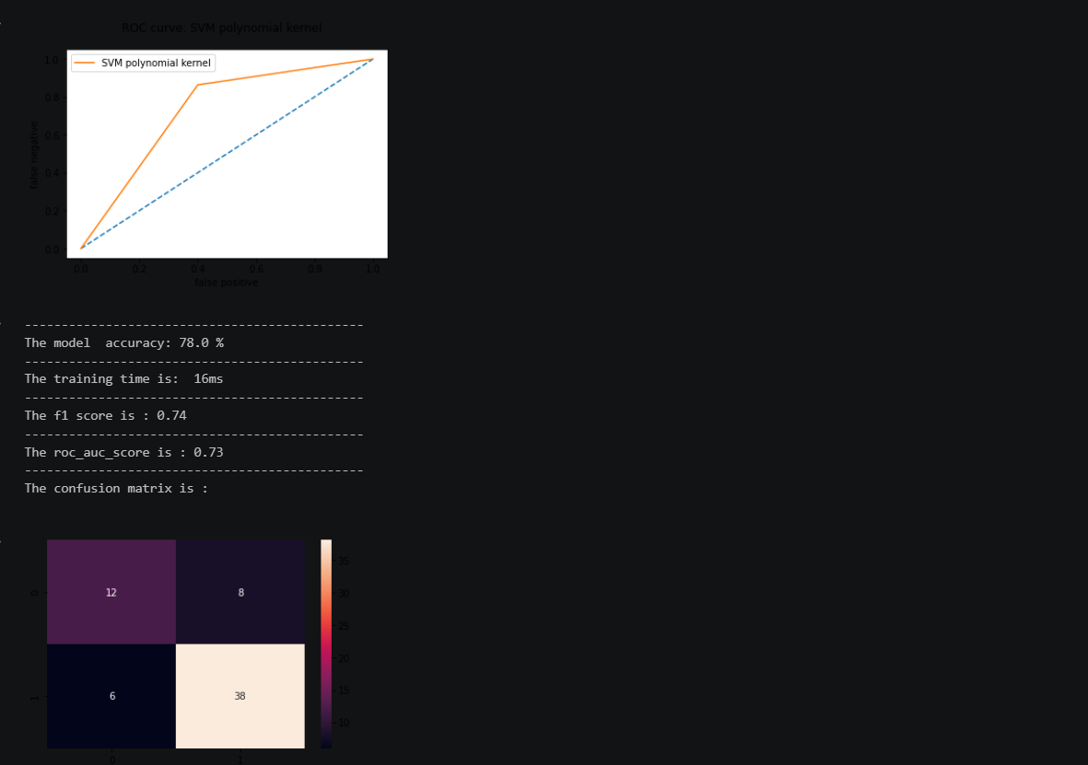
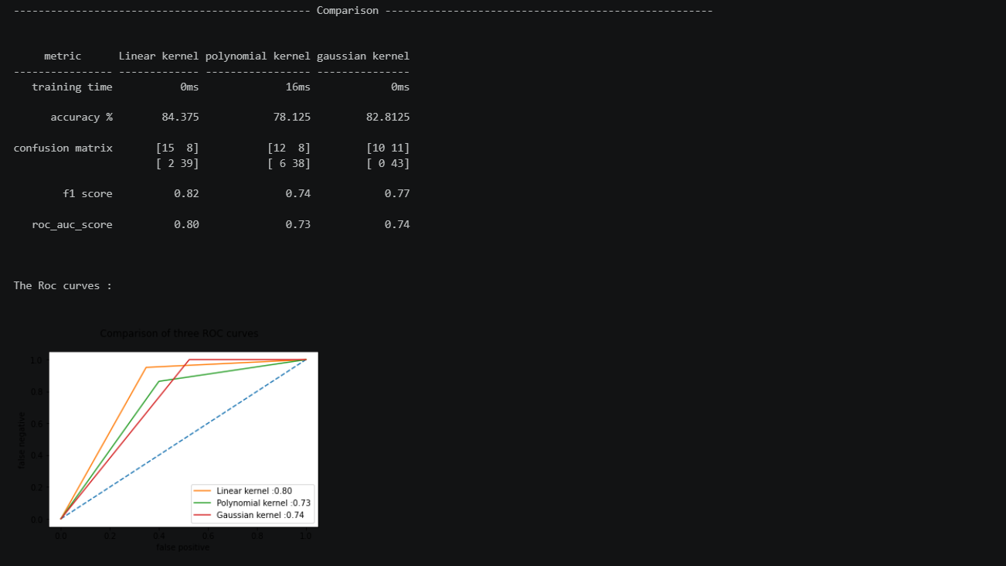

5. Major Findings / Outcomes / Results
5.1 Findings
- Support Vector Machine achieved the highest prediction accuracy among all implemented models.
- K-Nearest Neighbours provided balanced performance with good precision and recall values.
- Logistic Regression produced stable and interpretable classification results.
- Data preprocessing techniques significantly improved model performance and prediction accuracy.
- Student attributes such as attendance, study time, and previous grades strongly influenced academic performance prediction.
- Machine learning techniques effectively identified academically weak students at an early stage.
- The system reduced manual effort in analysing student academic data.

5.2 Results
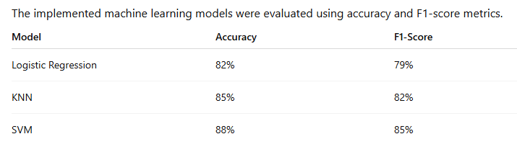
5.3 Outcomes of the Project
- Developed a machine learning-based student performance prediction system.
- Successfully implemented Logistic Regression, KNN, and SVM algorithms.
- Improved academic performance analysis using predictive techniques.
- Enabled early identification of students who may require academic support.
- Achieved efficient and accurate classification of student performance.
- Supported data-driven educational decision-making.
- Demonstrated the importance of machine learning in educational systems.

5.4 Result Analysis
- SVM achieved the best overall performance with the highest accuracy.
- KNN showed balanced classification performance.
- Logistic Regression provided reliable and interpretable results.
- The experimental results demonstrate that machine learning techniques can effectively predict student academic performance and support educational institutions in improving student outcomes
6. Conclusion
This project demonstrates the effectiveness of Machine Learning techniques in predicting student academic performance using educational data. The system analyzes important student-related factors such as attendance, study time, and previous grades to predict academic outcomes accurately.
Three machine learning algorithms—Logistic Regression, K-Nearest Neighbors, and Support Vector Machine—were implemented and compared. Among all models, SVM achieved the highest accuracy, while KNN provided balanced classification performance.
The project highlights the importance of data preprocessing, feature selection, and model evaluation in improving prediction accuracy. The developed system can help educational institutions identify academically weak students at an early stage and support better academic decision-making through data-driven analysis.
Overall, the project successfully demonstrates how machine learning can improve educational systems by providing efficient and accurate student performance prediction.

7. Future Scope
The project “Predicting Student Academic Performance Using Machine Learning Techniques” can be improved further by integrating advanced technologies and larger educational datasets. Future enhancements can make the prediction system more accurate, efficient, and intelligent.

Future Improvements
- Implementation of deep learning algorithms for improved prediction accuracy.
- Use of larger and real-time educational datasets for better analysis.
- Integration with smart educational management systems.
- Development of real-time student performance monitoring systems.
- Addition of personalized learning recommendations for students.
- Implementation of visualization dashboards for teachers and institutions.
- Development of mobile-based academic monitoring applications.
- Integration of attendance tracking and assignment analysis modules.
- Use of cloud-based storage and online prediction systems.
- Enhancement of prediction models using hybrid machine learning techniques.
These future enhancements can help educational institutions improve academic planning, student monitoring, and overall learning outcomes through intelligent prediction systems.

REFERENCES
- R. Baker and K. Yacef, “Educational Data Mining and Predictive Analytics,” Journal of Educational Technology.
- C. Cortes and V. Vapnik, “Support Vector Networks,” Machine Learning Journal, 1995.
- S. B. Kotsiantis, “Machine Learning: A Review of Classification and Combining Techniques,” Artificial Intelligence Review.
- T. Hastie, R. Tibshirani, and J. Friedman, The Elements of Statistical Learning, Springer.
- Scikit-learn Documentation
- UCI Machine Learning Repository
- Python Documentation
- Pandas Documentation
- NumPy Documentation
- Jupyter Notebook Documentation

APPENDICES
Appendix A – Dataset Description
The dataset used in this project was collected from the UCI Machine Learning Repository. The dataset contains academic and behavioural information related to student performance.

Dataset Attributes:
- Attendance
- Study Time
- Previous Grades
- Assignment Performance
- Classroom Participation
- Academic Records
The dataset was used for training and testing the machine learning models.

Appendix B – Machine Learning Algorithms Used
The following machine learning algorithms were implemented in the project:
- Logistic Regression
- Used for probability-based classification and prediction.
- K-Nearest Neighbours
- Used for similarity-based classification using neighbouring data points.
- Support Vector Machine
- Used for accurate classification by identifying the best decision boundary.

Appendix C – Evaluation Metrics
The following evaluation metrics were used to measure model performance:
- Accuracy
- Precision
- Recall
- F1-Score
- Confusion Matrix
These metrics helped compare the effectiveness of different machine learning models.

